REAL STORIES: DISABILITY DISCRIMINATION – COMPLAINTS, CHALLENGES AND OUTCOMES

Come along and listen to the stories of Disability Discrimination Legal Service clients who made discrimination complaints, as they share their journeys and experiences. There will be time to ask questions and find out how to make a disability discrimination complaint.

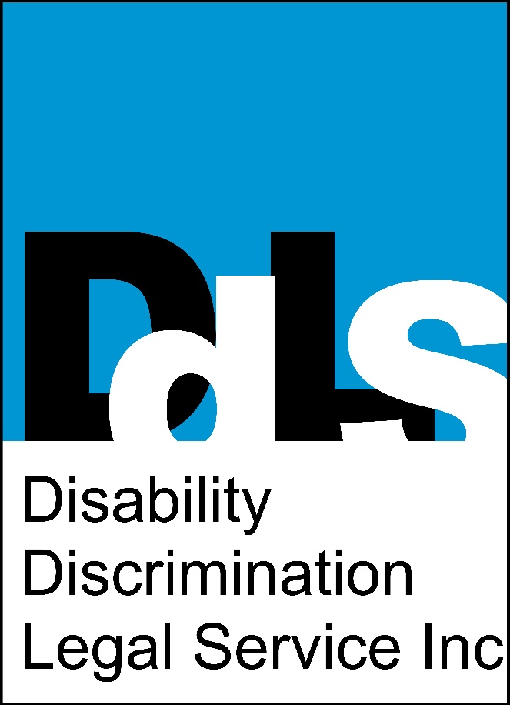
Thursday 19th May 2016
2pm - 3:30pm

Room 1.1, level 1,
Ross House
247 Flinders Lane, Melbourne

Bookings recommended: please contact Deborah Randa on 9654 8644 or email solicitor@ddls.org.au to book.
EQUALITY AND JUSTICE FOR
PEOPLE WITH DISABILITIES

